

Phonebook (contacts)

*



January 14, 2021

Sir Rana marwat

M.FAHAD ABID

SAP ID #14674

Phonebook is a simple application which is used to communicate with each other It is available in all cell phones even in Windows & Mac. Phone book perform specific function like (searching, sorting, updating &deletion).

Details: In detail, The functions are to add new records, listing them, modifying them and updating, search for contacts, and deleting the contact.

This project facilitie the user to record personal information such as name, phone number while adding a record into the Phonebook. These records can then be modified, listed, searched for, and removed in the application.

CODE::

#include<iostream>

#include <string>

using namespace std;

void menu()

{

cout<<"\nTo Add contact press 1"<<endl;

cout<<"To Display contacts press 2"<<endl;

cout<<"To Search a Contact press 3"<<endl;

cout<<"To Delete Contact press 4"<<endl;

}

struct node

{

string name,num;

node *next;

};

node *head = NULL , *thenode , *address;

int a = 0 ;

void Mainfun()

{

thenode = new node;

cout<<"Enter Name:-";

cin>>thenode->name;

cout<<"Enter Number:-";

cin>>thenode->num;

thenode->next = NULL;

if(head == NULL)

{

head = thenode;

address = thenode;

}

else

{

address->next= thenode;

address = thenode;

}

}

void Display()

{

if(head == NULL)

{

cout<<"No contact's found!"<<endl;

}

else

{

cout<<"Detail's"<<endl;

node *dis = head ;

while (dis != NULL)

{

cout<<"\nName:-"<<dis->name<<endl;

cout<<"Number:-"<<dis->num<<endl;

dis= dis->next;

a++;

}

cout<<"Your Contacts are:-"<<a<<endl;

}

}

void Search()

{

node *search= head;

string cont;

int count = 1;

cout<<"To Search Contact Enter Position:-";

cin>>cont;

bool found = false;

if(head == NULL)

{

cout<<"Not Found!"<<endl;

}

else

{

while (search != NULL)

{

if(cont == search->name || cont == search->num)

{

cout<<"\n Name:-"<<search->name<<endl;

cout<<"Number:-"<<search->num<<endl;

found =true;

break;

}

search = search->next;

count++;

}

}

if(found == true)

{

cout<<"Position of Contact =:-"<<count<<endl;

}

else

{

cout<<"Contact Not Found!"<<endl;

}

}

void Delete()

{

int del ;

node *cont;

address = head;

cout<<"To Delete Contact Enter Position:-"<<endl;

cin>>del;

if(head==NULL)

{

cout<<"List is Empty"<<endl;

}

else if (del>a)

{

cout<<"Invalid Position!"<<endl;

}

else if(del==0)

{

address = head;

head = head->next;

delete address;

cout<<"Contact deleted!"<<endl;

}

else

{

for (int a = 1 ; a<del ; a++)

{

address = address->next;

}

cont = address->next;

address->next = cont->next;

delete cont;

cout<<"Contact deleted"<<endl;

}

}

void main() //main finction

{

cout<<"********************Welcome to the app********************"<<endl;

cout<<"********************You are using contacts by Fahad********************"<<endl;

cout<<"MENU"<<endl;

int b;

while (true)

{

menu();

cin>>b;

switch (b)

{

case 1:

Mainfun();

break;

case 2:

a = 0;

Display();

break;

case 3:

Search();

break;

case 4:

Delete();

break;

default:

cout<<"Select Again!"<<endl;

}

}

}

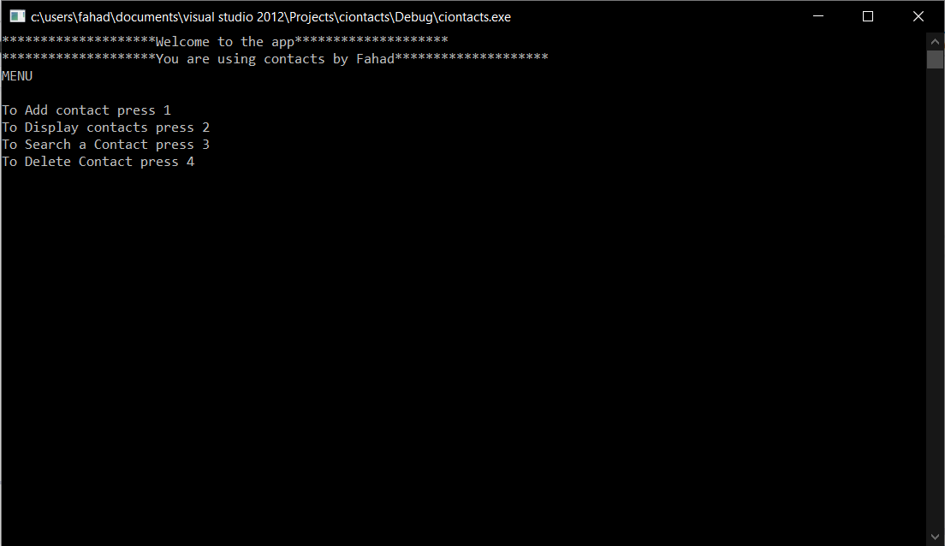OUTPUT:

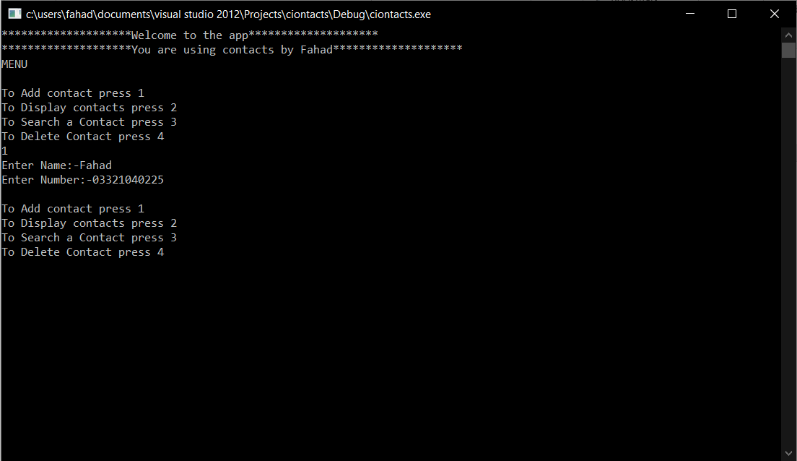

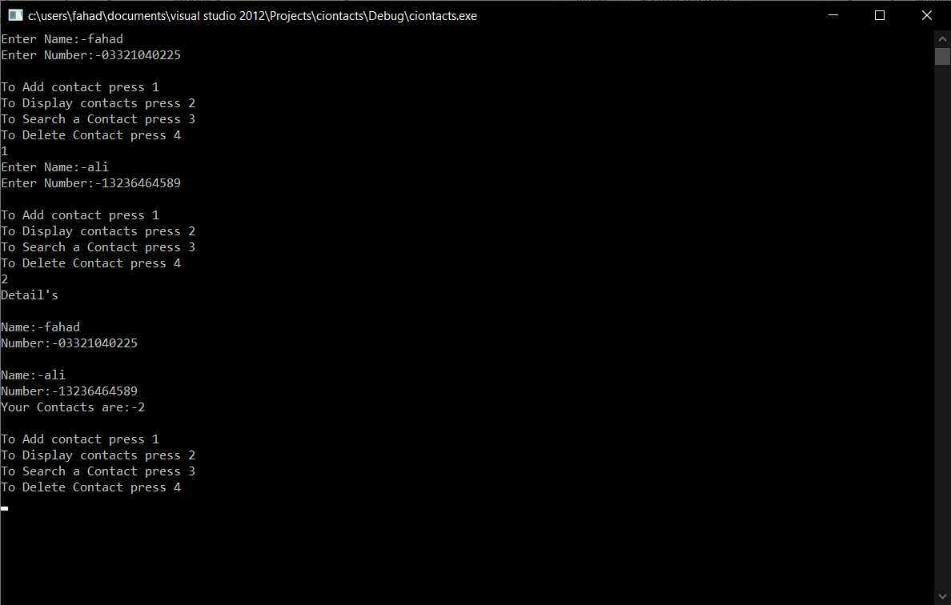

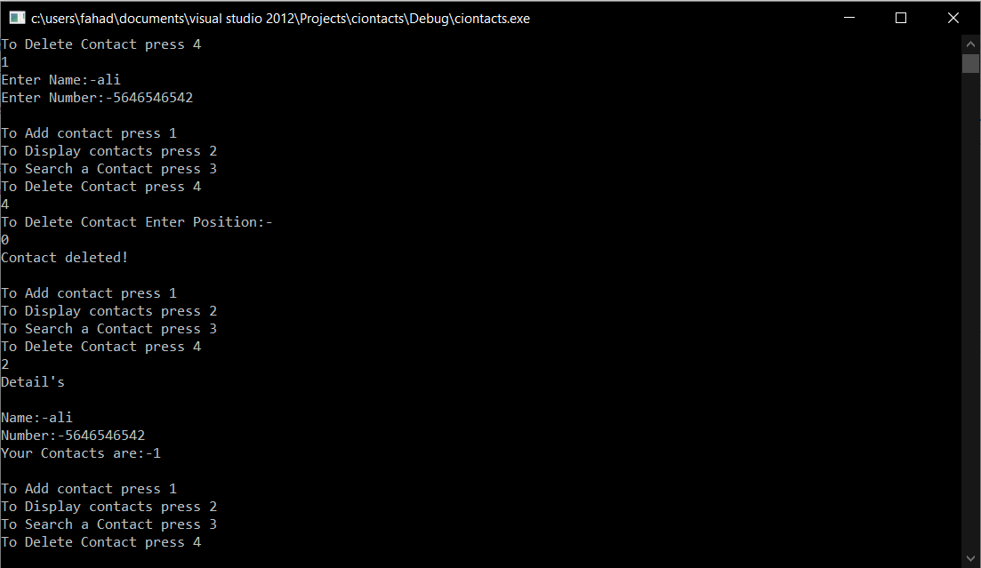

My code is 100% working if there is an error you can contact me on github

Link: [https://github.com/M-Fahad-Abid?tab=projects](https://github.com/M-Fahad-Abid?tab=projects%20)